**US Mass Shootings**

The United States stands out as an exceptional case in terms of gun violence. Gun violence has been allowed to escalate into a human rights crisis by successive US governments. It has been referred to as a distinctive American epidemic. Mass shootings do not have to be an unavoidable aspect of American society. Similar to other tragic instances of gun violence, we can prevent them by implementing rational policy solutions. The loss of life represented by these incidents is only a fraction of the overall fatal violence occurring annually in the US. Within the past decade, shocking records have been established. However, there are few indications at either the state or federal level, apart from a few exceptions, that significant policy changes are imminent. Nevertheless, mass killings are occurring with alarming frequency. To demonstrate the scale of everyday gun violence, this report examines the changing trend between 2017 and 2022 in the total number of shootings, fatalities, and injuries. Despite various measures taken to tackle gun violence in the United States, the occurrence of shootings, fatalities, and injuries remains high, exhibiting notable variations among different areas.

**Contents**

**Project Overview**

**Problem Statement**

**KPI and Data Dictionary**

**Executive Summary and the problems that occurred during the project.**

**Key Insights**

**Recommendations**

**Deployment**

**Project Overview**

Gun violence in the United States stands out as an anomaly. The US governments have allowed the proliferation of gun violence, transforming it into a crisis that violates human rights. It has been described as a uniquely American epidemic. Mass shootings do not have to be an unavoidable aspect of American life. Like other tragic forms of gun violence, they can be prevented through sensible policy solutions. The casualties caused by such incidents represent only a fraction of the fatal violence that takes place in the US each year. Shocking records have been established within the past decade. However, there are few signs, except for a few isolated cases, that major policy changes are imminent at either the state or federal level. Nevertheless, mass killings continue to occur at an alarming rate. This report analyzes the changing trend between 2017 and 2022, examining the total number of shootings, fatalities, and injuries, in order to highlight the magnitude of everyday gun violence. Despite various measures taken to combat gun violence in the United States, the number of shootings, fatalities, and injuries remains high, with significant variations observed among different states.

**Problem Statement**

The Gun Violence Archive, a non-profit research group, defines a mass shooting as any incident where four or more people are shot (excluding the shooter), regardless of fatality. According to the Pew Research Center, the FBI noted a rise in active shooter incidents from 2000 to 2020. In 2000, there were three such incidents, whereas by 2020, the number had increased to 40, illustrating a significant surge in gun violence nationwide. Several factors contribute to the high rate of gun violence in the US, including a cultural affinity towards gun ownership and the absence of comprehensive federal-level gun control laws. While other countries have also witnessed prominent mass shootings, many have implemented stringent gun control regulations that have helped reduce the overall incidence of gun violence. Unfortunately, the United States lags behind in this regard. This highlights the persistent issue of gun violence and underscores the imperative need for effective measures to address it.



**KPIs**

[KPIs in data analytics](https://www.forbes.com/sites/forbestechcouncil/2021/11/22/key-performance-indicators-kpis-the-lynchpin-in-enterprise-data-analytics/?sh=f377bca7704f)

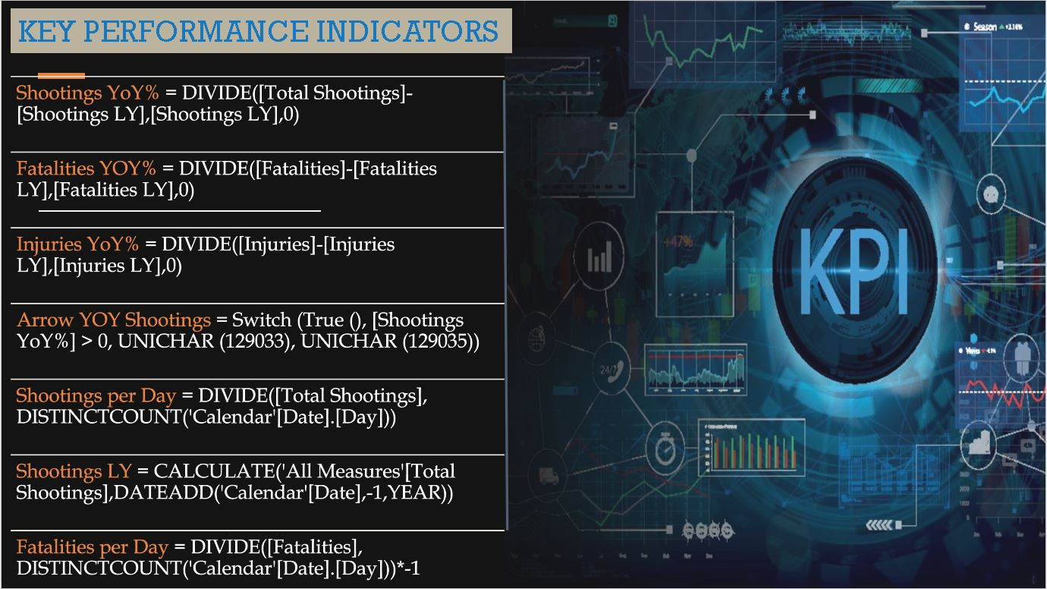

| **Measure** | **DAX Formula** |
| --- | --- |
| **Fatalities** | **SUM(US_Shootings[Dead])** |
| **Fatalities ColorByIncreaseDecrease** | **VAR currentValue = [Fatalities YOY] -- Replace [YourMeasure] with your actual measure name**  **RETURN**  **IF(ISBLANK(currentValue) ,**  **BLANK(),**  **IF(currentValue > 0,**  **"Red", -- Set the color to green if the current value is greater than the previous value**  **IF(currentValue < 0,**  **"Green", -- Set the color to red if the current value is less than the previous value**  **"Black" -- Set a default color if the values are equal**  **)**  **)**  **)** |
| **Fatalities Per Day** | **DIVIDE(SUM(US_Shootings[Dead]),DISTINCTCOUNT(Calendar[Date].[Day]))*-1** |
| **Fatalities YOY** | **DIVIDE((([Total Fatalities]*-1)-([Previous Year Fatalities])*-1),([Previous Year Fatalities])*-1,0)** |
| **Fatalities Yoy Arrow** | **VAR currentValue = [Fatalities YOY] // Replace [YourMeasure] with your actual measure name**  **RETURN**  **IF(ISBLANK(currentValue),**  **".",**  **IF(currentValue > 0,**  **UNICHAR(9650), // Up arrow Unicode character**  **IF(currentValue < 0,**  **UNICHAR(9660), // Down arrow Unicode character**  **"."**  **)**  **)**  **)** |
| **Incidents ColorByIncreaseDecrease** | **VAR currentValue = [Incidents YOY] -- Replace [YourMeasure] with your actual measure name**  **RETURN**  **IF(ISBLANK(currentValue) ,**  **BLANK(),**  **IF(currentValue > 0,**  **"Red", -- Set the color to green if the current value is greater than the previous value**  **IF(currentValue < 0,**  **"Green", -- Set the color to red if the current value is less than the previous value**  **"Black" -- Set a default color if the values are equal**  **)**  **)**  **)** |
| **Incidents YOY** | **DIVIDE(([Total Incidents]-[Previous Year Incidents]),[Previous Year Incidents],0)** |
| **Incidents Yoy Arrow** | **VAR currentValue = [Incidents YOY] // Replace [YourMeasure] with your actual measure name**  **RETURN**  **IF(ISBLANK(currentValue),**  **".",**  **IF(currentValue > 0,**  **UNICHAR(9650), // Up arrow Unicode character**  **IF(currentValue < 0,**  **UNICHAR(9660), // Down arrow Unicode character**  **"."**  **)**  **)**  **)** |
| **Injured ColorByIncreaseDecrease** | **VAR currentValue = [Injured YOY] -- Replace [YourMeasure] with your actual measure name**  **RETURN**  **IF(ISBLANK(currentValue) ,**  **BLANK(),**  **IF(currentValue > 0,**  **"Red", -- Set the color to green if the current value is greater than the previous value**  **IF(currentValue < 0,**  **"Green", -- Set the color to red if the current value is less than the previous value**  **"Black" -- Set a default color if the values are equal**  **)**  **)**  **)** |
| **Injured YOY** | **DIVIDE(([Total Injured]-[Previous Year Injured]),[Previous Year Injured],0)** |
| **Injured Yoy Arrow** | **VAR currentValue = [Injured YOY] // Replace [YourMeasure] with your actual measure name**  **RETURN**  **IF(ISBLANK(currentValue),**  **".",**  **IF(currentValue > 0,**  **UNICHAR(9650), // Up arrow Unicode character**  **IF(currentValue < 0,**  **UNICHAR(9660), // Down arrow Unicode character**  **"."**  **)**  **)**  **)** |
| **Previous Year Fatalities** | **CALCULATE([Total Fatalities],DATEADD(calendar[Date],-1,YEAR))** |
| **Previous Year Incidents** | **CALCULATE([Total Incidents],DATEADD('Calendar'[Date],-1,YEAR))** |
| **Previous Year Injured** | **CALCULATE([Total Injured],DATEADD(calendar[Date],-1,YEAR))** |
| **Shootings Per Day** | **DIVIDE(COUNT(US_Shootings[Date]),DISTINCTCOUNT(Calendar[Date].[Day]))** |
| **Total Fatalities** | **SUM(US_Shootings[Dead])*-1** |
| **Total Incidents** | **COUNTX(US_Shootings,US_Shootings[Date])** |
| **Total Injured** | **SUM(US_Shootings[Injured])** |

**Data Dictionary**



**Executive Summary**

**Problems Encountered**

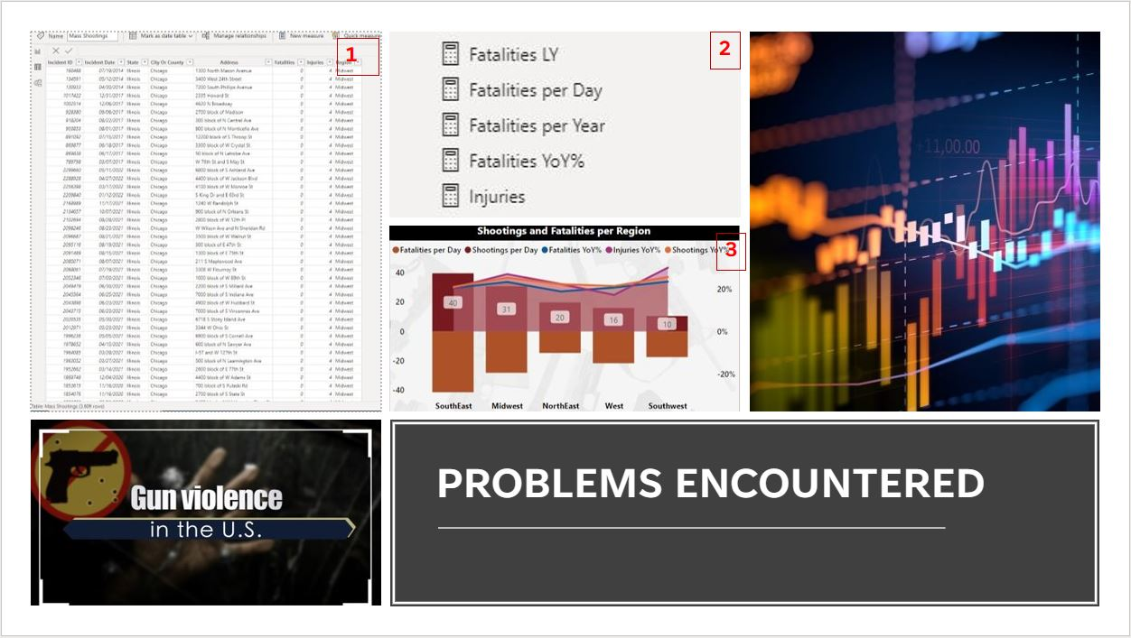

1. The initial challenge I faced was finding a suitable dataset. Despite my attempts to avoid it, I kept coming back to this particular dataset, which resonated with me on a personal level as a survivor of gun violence. Hence, I ultimately realized that this dataset was the most fitting choice for my project.
2. Developing DAX formulas proved to be a demanding task that required significant effort. I dedicated considerable time to refining and adjusting the measures in order to make sense of the data. Through multiple iterations and corrections, I not only achieved the desired formulas but also deepened my understanding of DAX.
3. The top right chart, depicting Shootings and Fatalities per Region, presented a significant challenge as the lines consistently remained at the top. Despite various attempts to rectify this issue by revisiting the dataset and measures, the behavior persisted. Eventually, I decided to present the chart as it is, as the underlying data and findings were accurate.

**Key Insights & Takeaways**

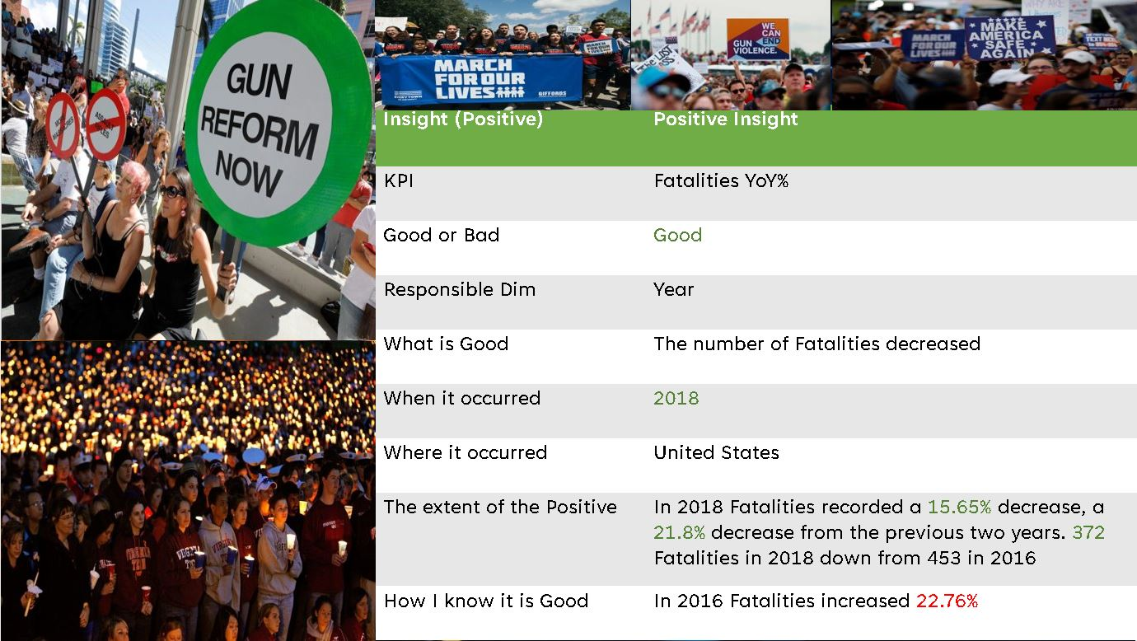

Among the states in the Southwest Region, Oklahoma reported the lowest year-over-year (YoY) injuries, with zero recorded fatalities. Oklahoma experienced no increase in fatalities (0.00%), and there was only a slight rise in injuries (5.19%).

Within the Southeast Region, West Virginia had the lowest average number of shootings per day and fatalities per day, both at 0. Following closely behind, Mississippi reported an average of 2 shootings per day and 3 fatalities per day.

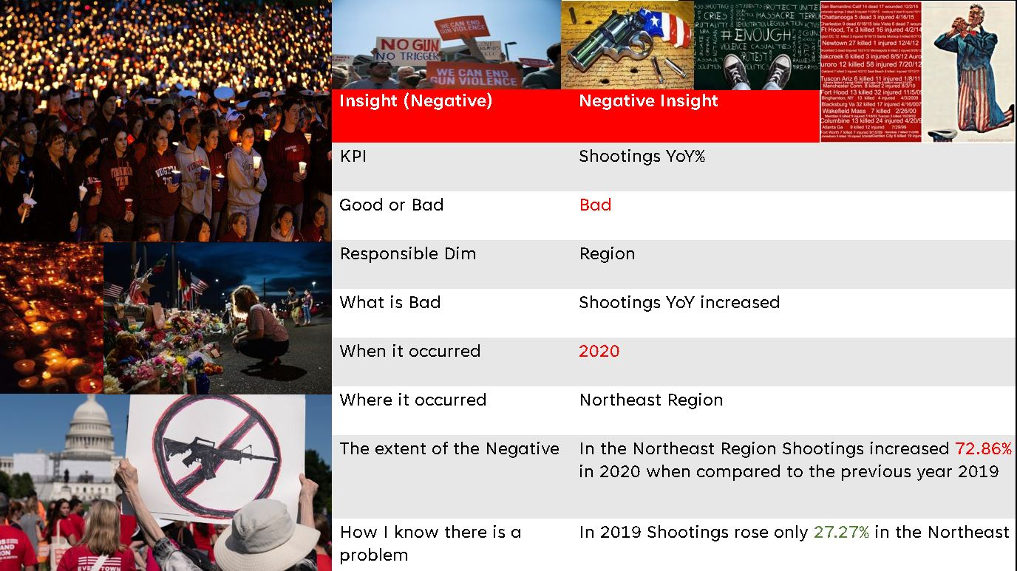

Among the cities in New York, the Bronx has the highest year-over-year (YoY) fatalities and shootings at 75% and 33.33% respectively, surpassing other cities in the state. In California, which has the highest numbers of fatalities and injuries in the state, the city of Fresno stands out with a YoY increase in fatalities at 50% and shootings at 28.57%.

**Suggestions**

1. Making the purchase of a firearm comparable to buying a car is an important consideration. The process of becoming a legal gun owner in America is considerably easier than obtaining a driver's license. Over the past five decades, significant progress has been made in reducing motor-vehicle deaths through public-health interventions. Safer cars and stricter seat-belt laws have played a vital role in decreasing car fatalities. We can draw lessons from auto safety to address gun violence. Hence, I propose implementing more stringent requirements for firearm ownership. The government should establish a policy mandating that every buyer obtain a license, complete a registration of all purchases, and undergo at least a basic training program.
2. Based on the available data, there are noticeable year-to-year fluctuations in shootings and fatalities. To curb gun violence, it may be beneficial to impose stricter penalties and increase accountability for crimes involving firearms. The gun industry currently benefits from significant legal protections. In 2005, Congress passed the Protection of Lawful Commerce in Arms Act, shielding gun manufacturers and sellers from civil claims brought by gun violence victims. My recommendation is to hold manufacturers responsible for the misuse of their products, encouraging them to prioritize firearm safety. If any other consumer product caused 500 deaths annually, it would likely face strict regulations or even a ban. Hence, it is essential to treat firearms, which claim thousands of lives each year, with a similar level of scrutiny.
3. The data also indicates a rise in the number of shootings per day during the pandemic, increasing from 13 in 2019 to 20 in 2020. Year-over-year, shootings surged from 24.11% in 2019 to almost double at 46.28% in 2020. The economic distress caused by the pandemic led to widespread job losses and financial insecurity, contributing to increased stress, social isolation, and mental health issues. These factors, in turn, have fueled a rise in violent behaviors, including shootings. To address this, I recommend that the government invest in mental health resources and make them more accessible. This could involve allocating additional funding for mental health clinics, expanding access to counseling services, and implementing mental health education programs in schools.
4. According to a 2017 study published in the Journal of the American Medical Association, federal research funding for gun violence should have amounted to $1.4 billion between 2004 and 2015, based on mortality rates and funding levels for other leading causes of death. However, the actual funding received was only $22 million, a mere 1.6% of the projected amount. Comparatively, gun violence research received 5.3% of the federal funds allocated for motor-vehicle accidents, despite similar mortality rates. The restrictions on research funding have had detrimental consequences on our knowledge about gun violence. The data indicates that New York experienced the highest year-over-year increase in fatalities at 33.33%. Additionally, Illinois had the highest average shootings per day at 13, with a 28.50% increase in fatalities year-over-year. California followed closely with 12 shootings per day, a 20.12% increase in fatalities, and Texas with 9 shootings per day and a 27.74% increase in fatalities. In response to this issue, California established the nation's first state-funded firearms-violence research center as an urgent investment to seek answers. Therefore, I recommend that other states with similar high metrics consider investing in similar research centers.

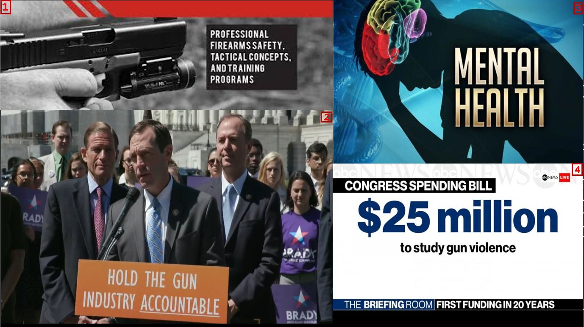

# 

# **Deployment**

